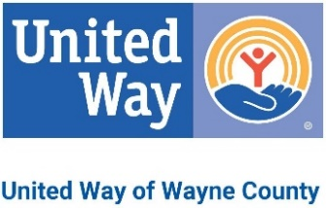
2023 Campaign Report
This Report Is: FINAL
A final report means your campaign is complete.
Please report only amounts contained in this envelope. A checklist is provided on the back for your assistance.

This Report Is: PARTIAL
A partial report means your campaign is still in progress.
Please report only amounts contained in this envelope.
A checklist is provided on the back for your assistance.

2022 Employee Investment: 2022 Corporate Investment:
Thank you for investing in our community through United Way of Wayne County.

For more information on how we are working together to improve lives, please visit unitedwayne.org
«AccountName»
Contact Information (please print clearly)
Address _____________________________________________________________________________________
Envelope prepared by:__________________________________________________________________________
E-mail Address ________________________________________________________________________________
Preparer's phone number ( ) ____Date __________________
Please Contact UWWC volunteer or staff for report pickup (919)735-3591
$
Column 2 TOTAL
4. SPECIAL EVENTS

5. TOTALS

6. Fair Share Entries # Total Fair Share amount $________

$
Column 1 TOTAL

1. COMPANY INFO
Total # employed by your company Total # investors
Total # Leadership Givers
(Annual investment of $500 or more)
Column 1
Total Gift/Pledge $
Column 2
Payment Enclosed $
2. CORPORATE GIVING
$
$
3. EMPLOYEE GIVING
Total Gift/Pledge $
Payment Enclosed $
(include all pledges & all payments) (include payments only)
a. Cash
$ $
b. Checks
$ $
c. Credit Cards
$
d. Direct Bills
$
e. Payroll Deductions
$
f. Stocks
$
$
NOTES
THANK YOU!

2803 Cashwell Drive, Suite B Goldsboro, NC 27534 (919)735-3591 phone (919)735-3654 fax
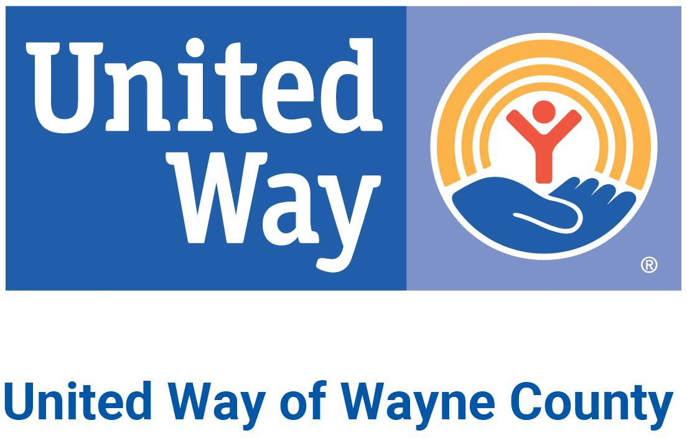
CAMPAIGN CHECKLIST

Did you fill out the entire report?

Did you enclose a signed copy of each pledge form?

Did you enclose completed and SIGNED Fair Share entries with appropriate pledge forms?

Did you send the white portion of the pledge forms for payroll deduction pledges to your payroll department? *Educators/WCPS employees send Reports/Pledges to Central Office HR department *

Does all information on this report balance with enclosed pledge cards?
Did you report special event income on appropriate line?
Did you make a copy of your campaign report for your records?

Questions/concerns please leave a comment on reverse side in "Notes" box

Thank You!
If you need immediate assistance, please call (919)735-3591

